There are 2 Ways of installing TestNG framework in Eclipse:
- Simple Way – Add Maven Dependencies in your POM.XML file:
<! -- TestNG Dependency: Source: https://mvnrepository.com/artifact/org.testng/testng -->
<dependency>
<groupId>org.testng</groupId>
<artifactId>testng</artifactId>
<version>7.12.0</version>
<scope>test</scope>
</dependency>

- Second way it to Install the plugin from the TestNG Website: https://testng.org/testng-eclipse/download.html
Copy+Paste URL on the website: https://testng.org/testng-eclipse-update-site
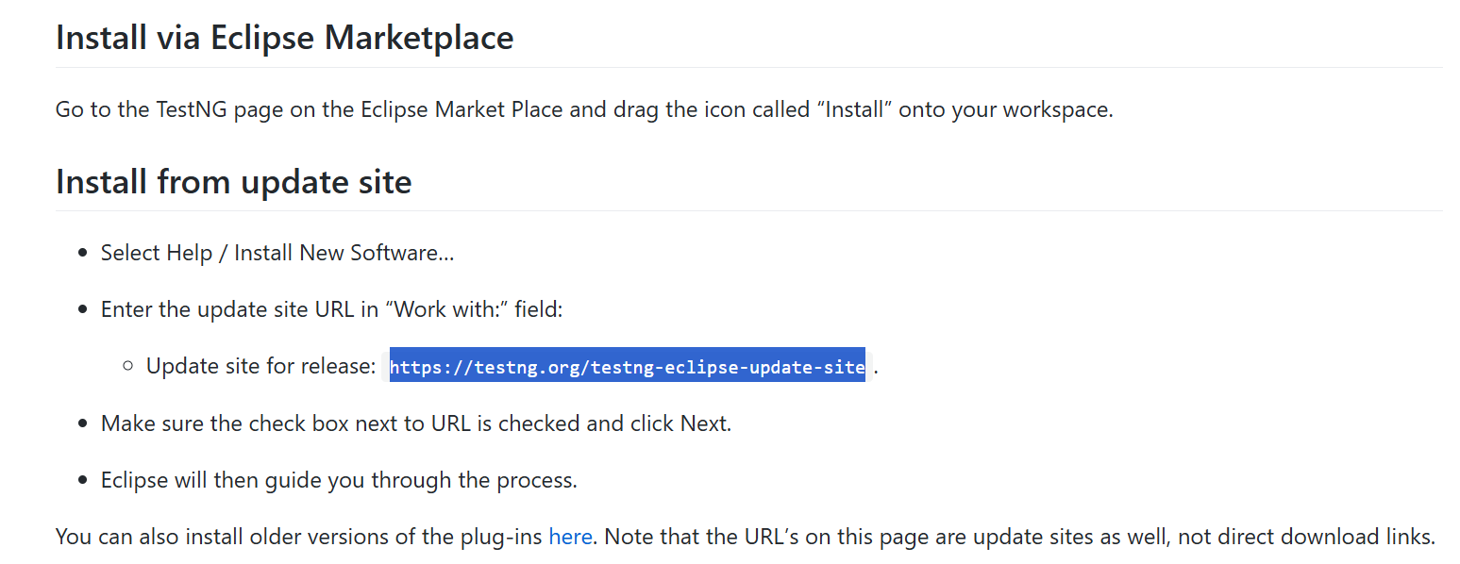
Open Eclipse and go to Help > Install New Software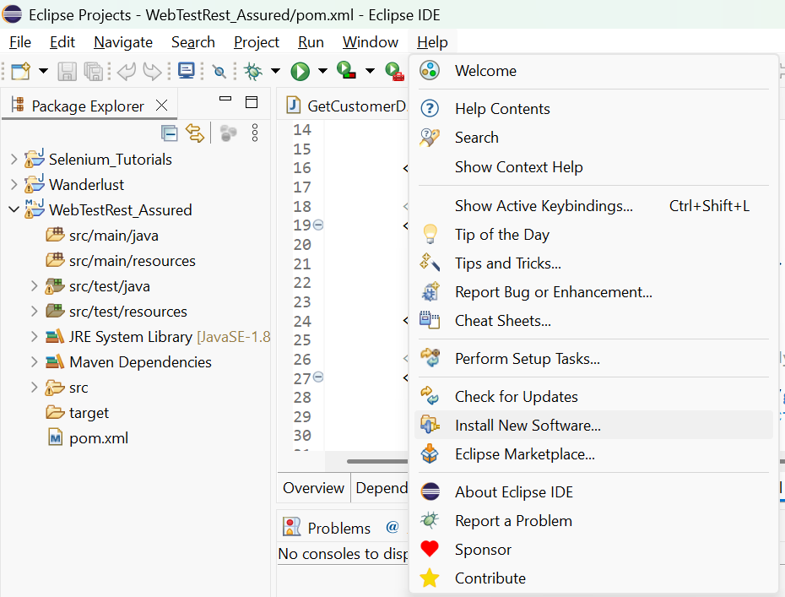

Paste that copied URL in the Work With: Window. As soon as you paste the URL, you will see the TestNG option is visible automatically. Select the TestNG check-box and Click on Next. 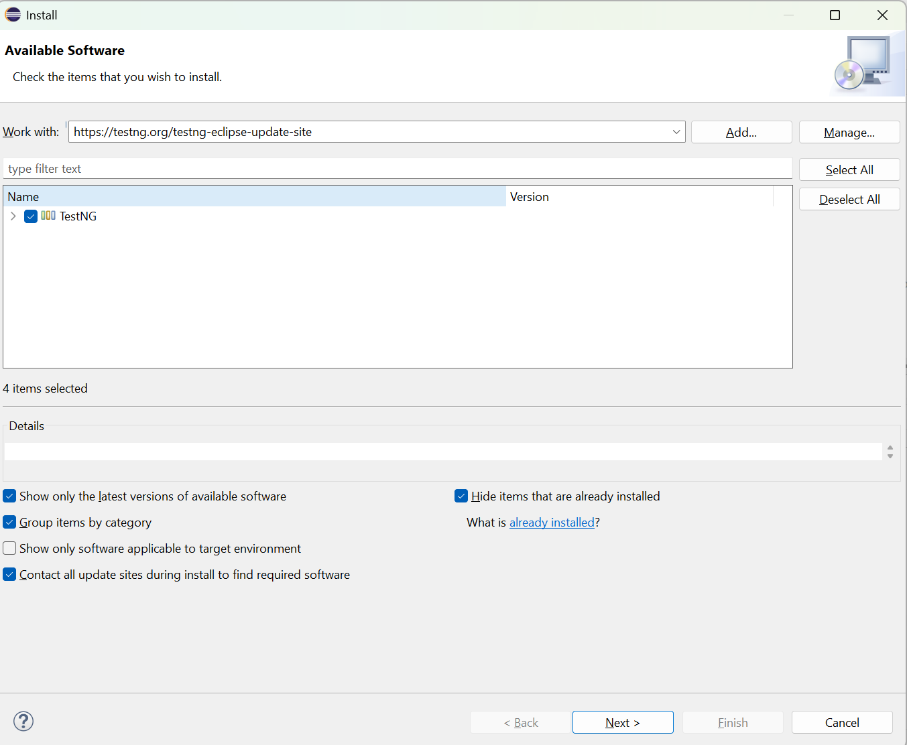

Click on Finish to complete the installations: 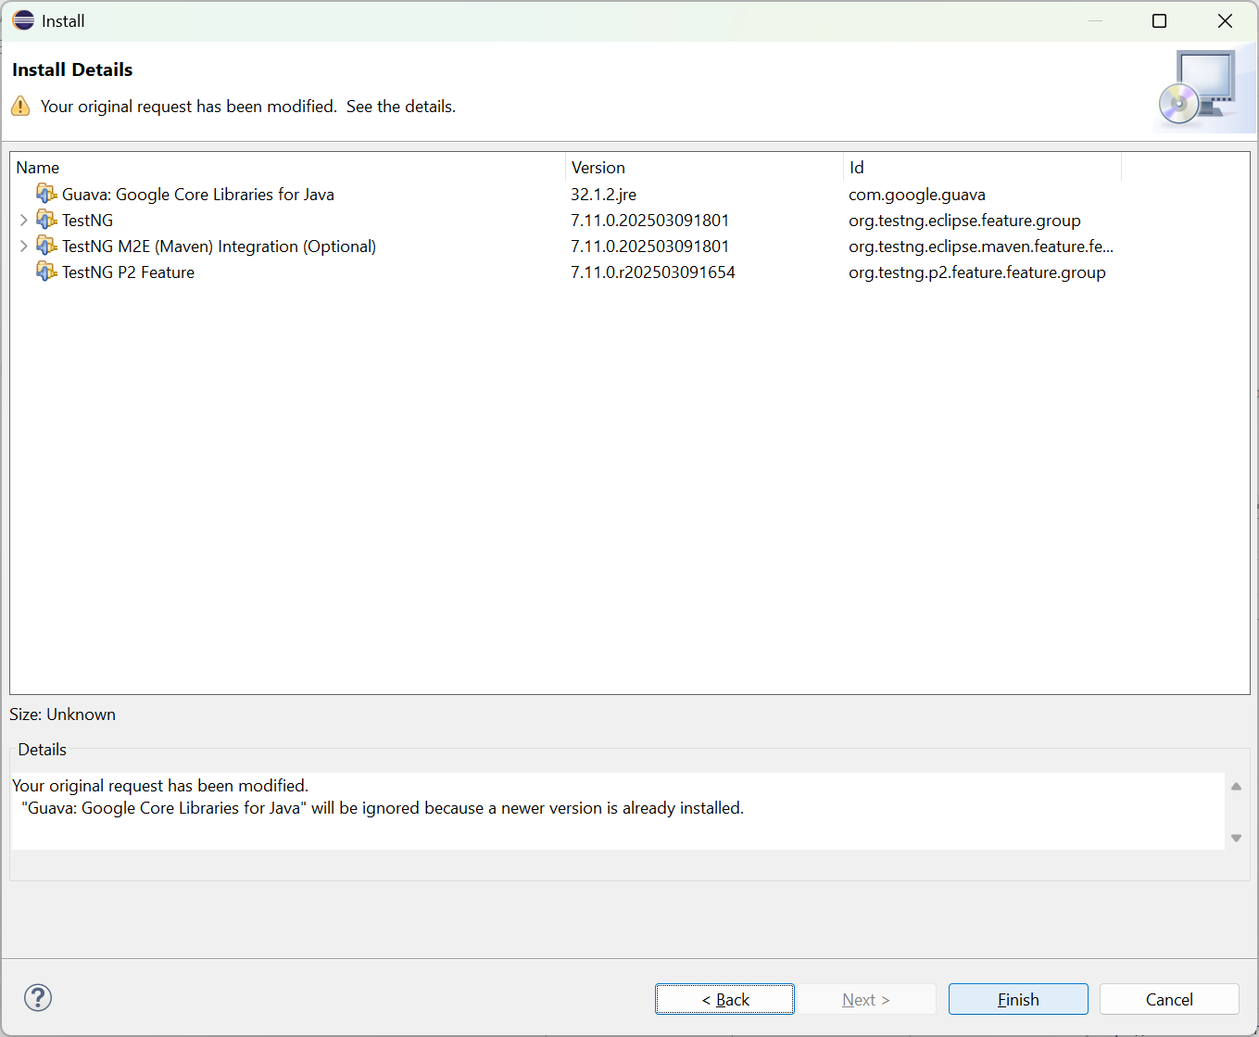

Once done, the TestNG option will be visible in 2 places:
1st is under Maven Dependencies
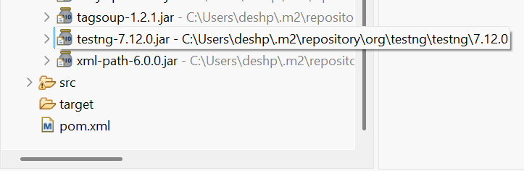

And 2nd is:
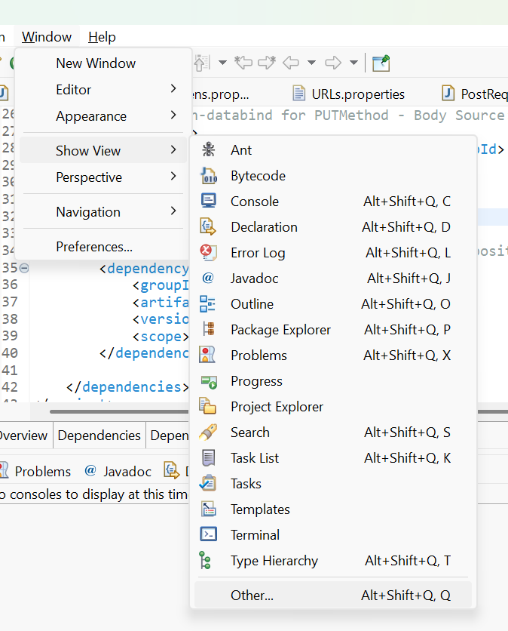

And under Java folder, TestNG should be visible.

